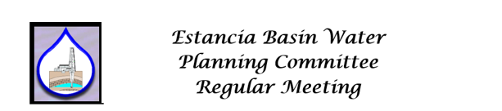
DRAFT AGENDA

Date and Time Location
Thursday Remote: Zoom Hybrid
February 9, 2023 Torrance County Courthouse
9:30 AM Estancia, NM

Approval of Agenda

Membership Issues / Appointments: Current Filled Positions: 10/13 Quorum: 6

Vacant Positions:
Santa Fe Governmental Rep
East Torrance SWCD
Torrance County – Agriculture

Nomination of Officers:

The EBWPC Rules of Conduct call for election of officers at the August meeting

Section 4.A. Each August, an election will be held within the Committee for electing a Chair, Vice Chair, and a Secretary/Treasurer. This election shall occur only after all members agencies have been advised of existing and upcoming vacancies.

The position of Chair is currently unfilled.
The position of Secretary is unfilled (and will not be served by Dan McGregor moving forward)
The position of Vice-Chair filled by Sherry Abraham
The position of Treasurer is filled by Don Goen with Torrance County

Nominations:
Motion to Approve New Officers:

Approval of Minutes of Previous Meetings: Approval of Minutes of Regular Meeting of October 13, 2022 and December 15, 2022– DUE TO LACK OF SECRETARY NO MINUTES WERE PREPARED. The agenda of Dec 15th was carried forward to the February agenda, and no actions were taken by the committee due to lack of quorum.

Financial Matters: Don Goen – Torrance County

Financial Report of November 30, 2022 and December 15 – NO INFORMATION WAS PROVIDED FROM TORRANCE COUNTY AS OF Dec 13, 2022

Santa Fe County funding MOU for FY23. – The MOU has been signed and routed back to Santa Fe County.

Invoicing letters have been sent to Estancia, Moriarty, and Town of Edgewood (7/8/2022 - no response to date, no additional information provided from Torrance County)

Approval of Financial Report/ Invoices:

Correspondence: None

Guests/Public Comments: None

Contractor/Subcommittee Reports: Groundwater monitoring program update – JSAI status (McGregor/Mellis). Transducer placement has been scheduled and is underway. A data transfer to the Office of the State Engineer to use in an update to the Estancia Basin administrative model has been approved and is underway.

Meetings Attended: None

Unfinished Business:

New Business: Open Meetings Resolution for 2023:
Motion for Approval

Discussion Only Items : Consideration of disbanding the EBWPC due to lack of participation/interest of the represented parties

Announcements:

Next Meeting

Date: Thursday, April 13, 2023 12:00 AM

Location: Torrance County Administrative Offices, 205 Ninth Street, Estancia NM

Plus Zoom hybrid

Adjourn

Minutes of 08/18/2022 For Approval
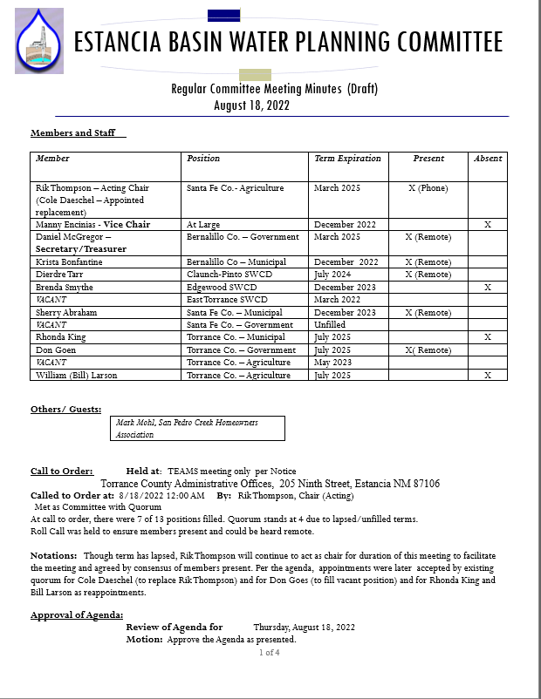

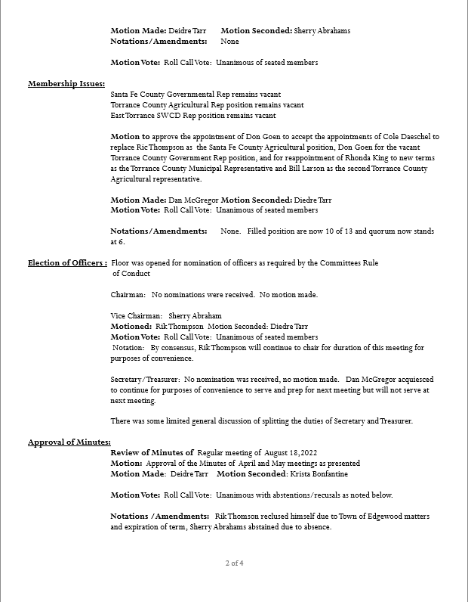

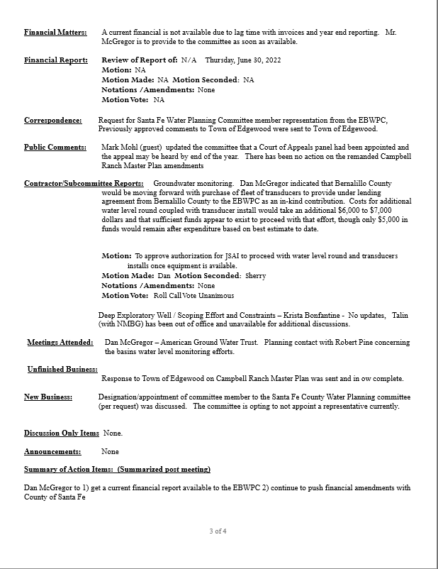

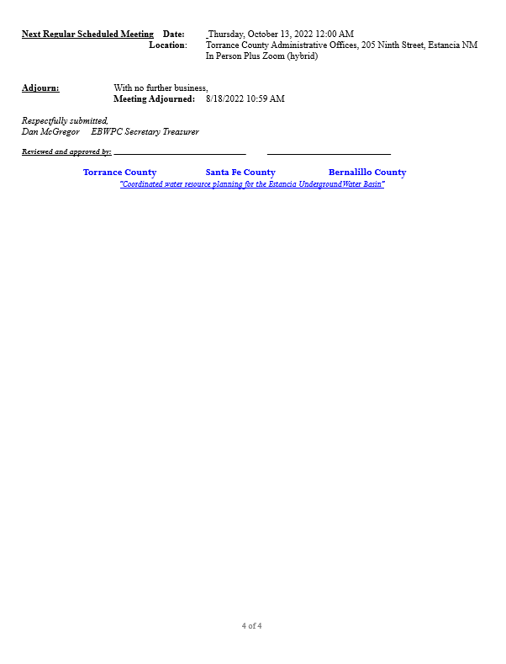

Financial Report For Approval

CORRESPONDANCE

